Activity 4_Violin_Skewness

Department | AI&DS
Course Code / Course Name | DSA0602/ Data Handling and Visualization
Activity | Activity 4_Violin_Skewness
Name | Addula Yaswanth
Register Number | 192324179

Part A – Identify Skewness Using Violin Plots
Rule to remember
Shape | Skew | Mean vs Median
Tail to right | Right skew | Mean > Median
Tail to left | Left skew | Mean < Median
Similar on both sides | Symmetric | Mean ≈ Median
The white dot represents the median.

Chart 1: Server Response (ms)

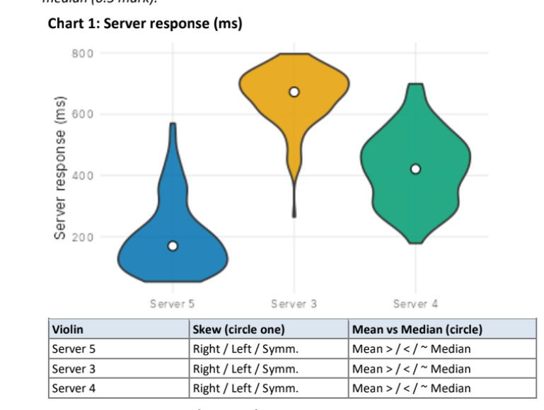
Violin | Skew | Mean vs Median
Server 5 | Right | Mean > Median
Server 3 | Left | Mean < Median
Server 4 | Symmetric | Mean ≈ Median

Explanation
- Server 5: Long tail extends toward higher response times → right skew.
- Server 3: Long tail extends toward lower response times → left skew.
- Server 4: Distribution is approximately balanced → symmetric.

Chart 2: Rainfall (mm)
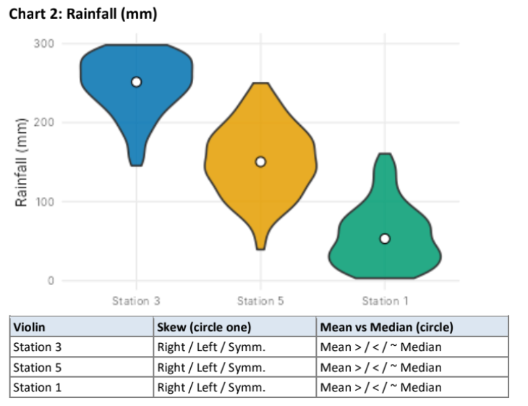
Violin | Skew | Mean vs Median
Station 3 | Left | Mean < Median
Station 5 | Symmetric | Mean ≈ Median
Station 1 | Right | Mean > Median

Explanation
- Station 3: Tail extends toward lower rainfall → left skew.
- Station 5: Shape is approximately balanced → symmetric.
- Station 1: Tail extends toward higher rainfall → right skew.

Chart 3: Delivery Time (minutes)
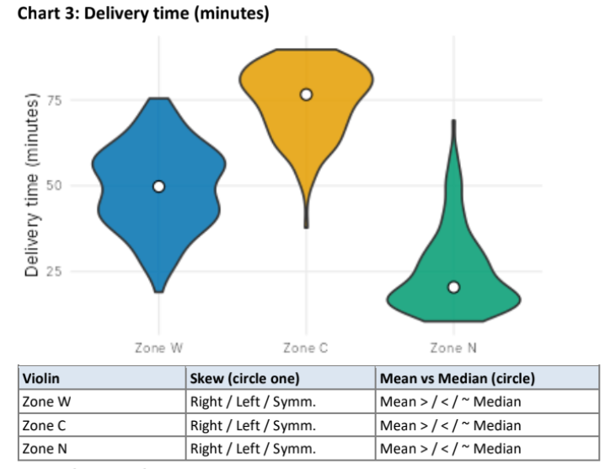
Violin | Skew | Mean vs Median
Zone W | Symmetric | Mean ≈ Median
Zone C | Left | Mean < Median
Zone N | Right | Mean > Median

Explanation
- Zone W: Approximately balanced distribution → symmetric.
- Zone C: Longer tail toward lower delivery times → left skew.
- Zone N: Longer tail toward higher delivery times → right skew.

Chart 4: Exam Marks (marks)
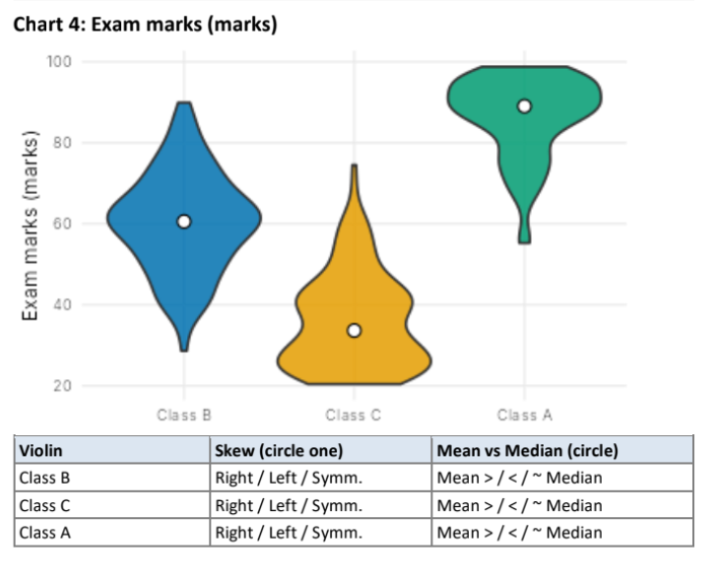
Violin | Skew | Mean vs Median
Class B | Symmetric | Mean ≈ Median
Class C | Right | Mean > Median
Class A | Left | Mean < Median

Explanation
- Class B: Approximately balanced → symmetric.
- Class C: Tail extends toward higher marks → right skew.
- Class A: Tail extends toward lower marks → left skew.
Part B
B1. Chart 2 – Station 3
Question: In Chart 2, violin "Station 3" is not symmetric. Towards which side is its tail, and which is the better measure of a typical rainfall here: mean or median? Give one reason.
Answer:
The tail of Station 3 extends toward the left side, so the distribution is left-skewed.
The median is the better measure of typical rainfall because the median is less affected by extreme values in the long tail.
Final answer:
Left tail → Left skew → Median is better.
B2. ggplot2 code
Question: Write one ggplot2 line that draws violins of value for each group from a data frame df with the median shown.
Answer:
ggplot(df, aes(x = group, y = value)) + geom_violin() + stat_summary(fun = median, geom = "point")

